1. Open Tableau Desktop
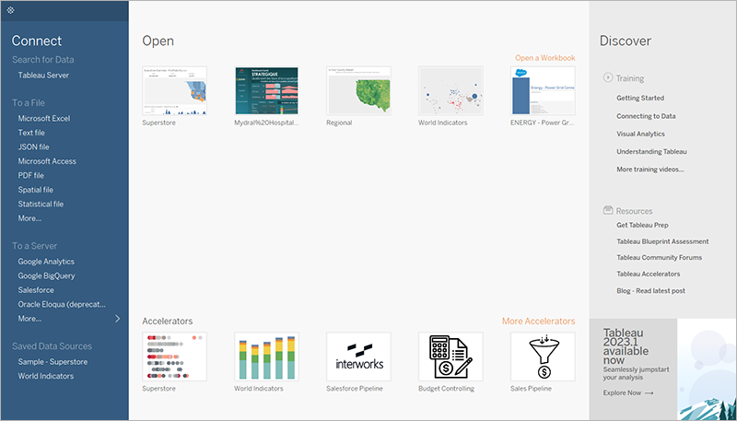
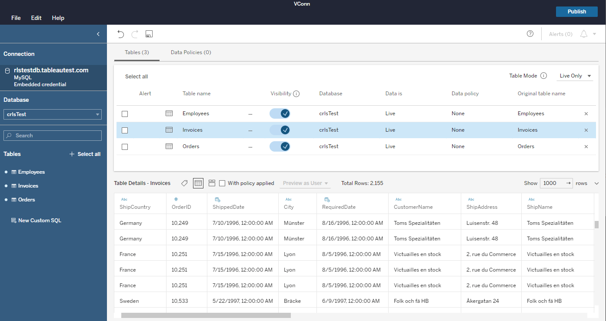
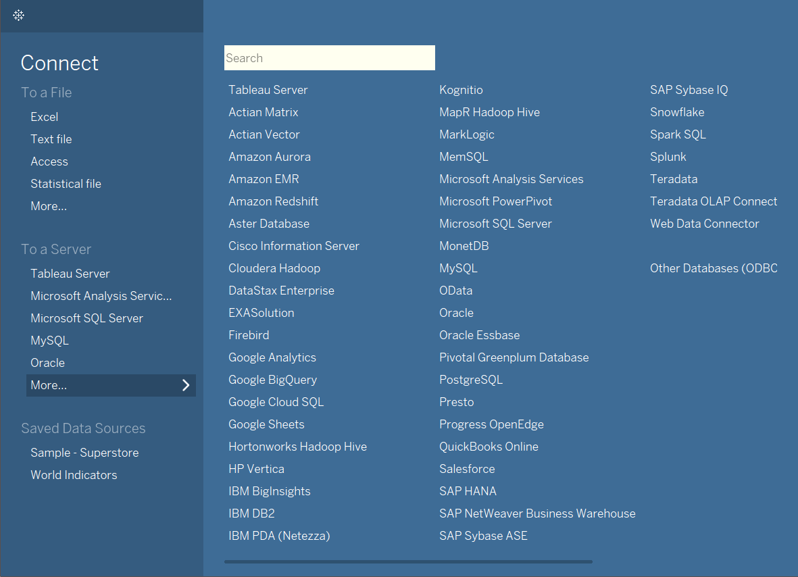
Steps
- Launch Tableau Desktop.
- On the left, you will see a panel labeled Connect.
- Under To a file, choose your dataset type, for example:
  - Microsoft Excel
  - Text file (CSV)
  - JSON

2. Connect to the tutorial dataset
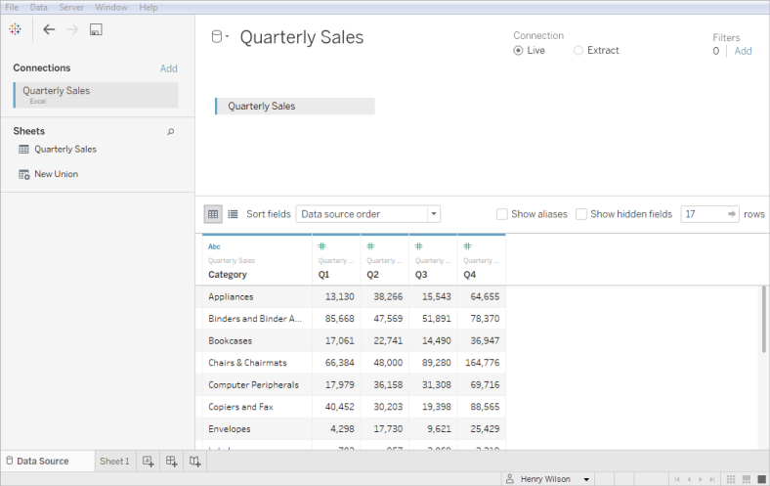
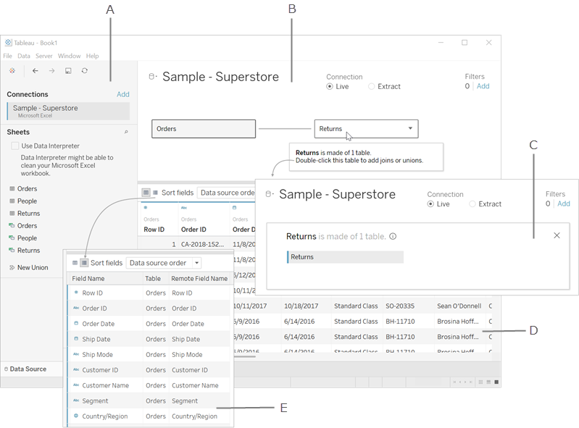
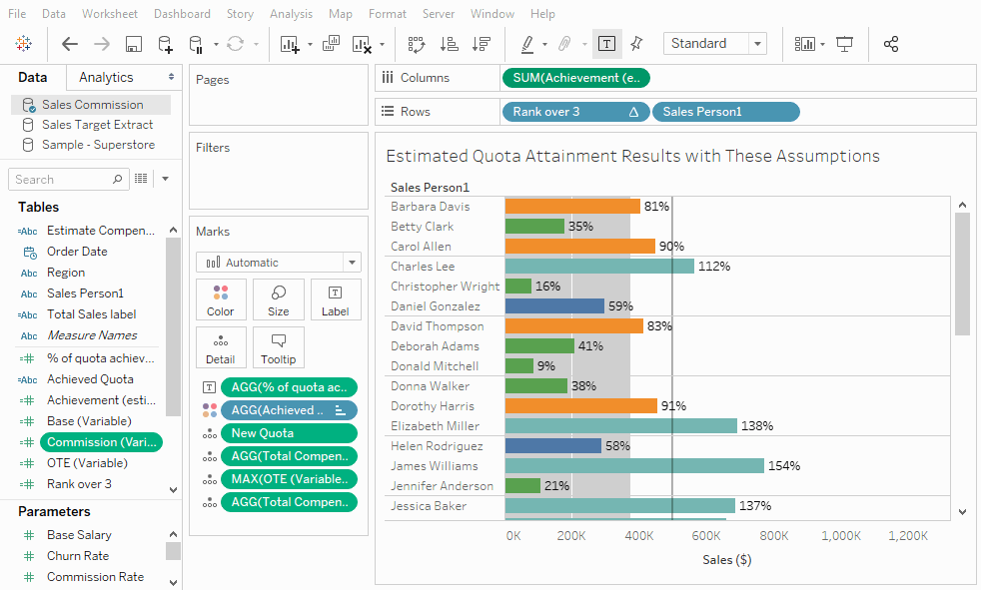
4
Steps
- Click Microsoft Excel if your dataset is an Excel file.
- Browse to your dataset, for example Sample_Superstore.xlsx.
- Tableau opens the Data Source page.
- Drag the worksheet (e.g., Orders) into the canvas area.
- You should see a preview of rows and columns at the bottom.

3. Navigate to a Worksheet
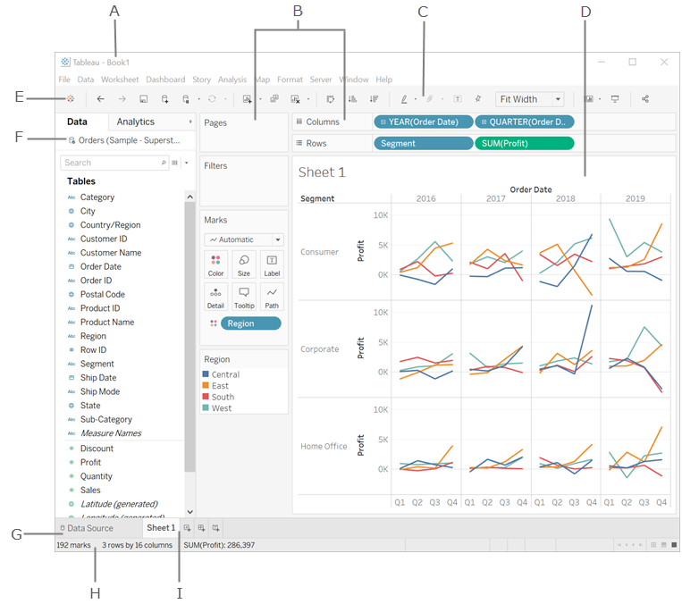
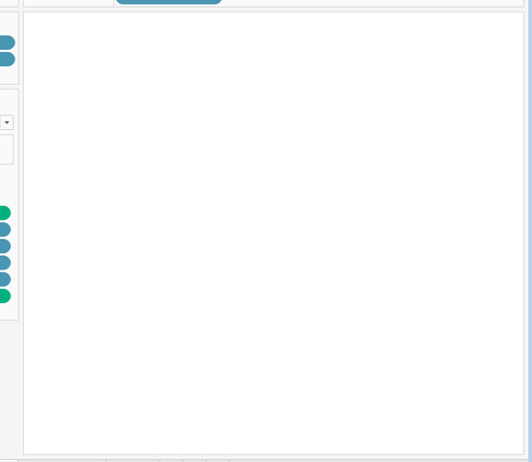
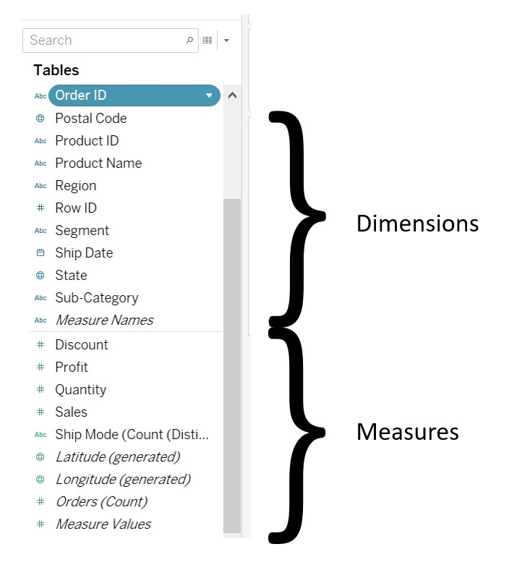
4
Steps
- At the bottom tabs, click Sheet 1.
- A blank worksheet appears.
- On the left, you see:
  - Dimensions (categorical fields like City, Category, Order Date)
  - Measures (numeric fields like Sales, Profit, Quantity)

4. Create your first charts
A. Bar chart: Sales by Category
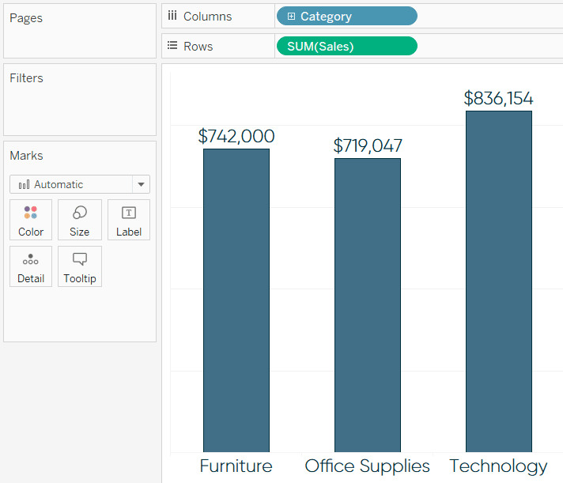
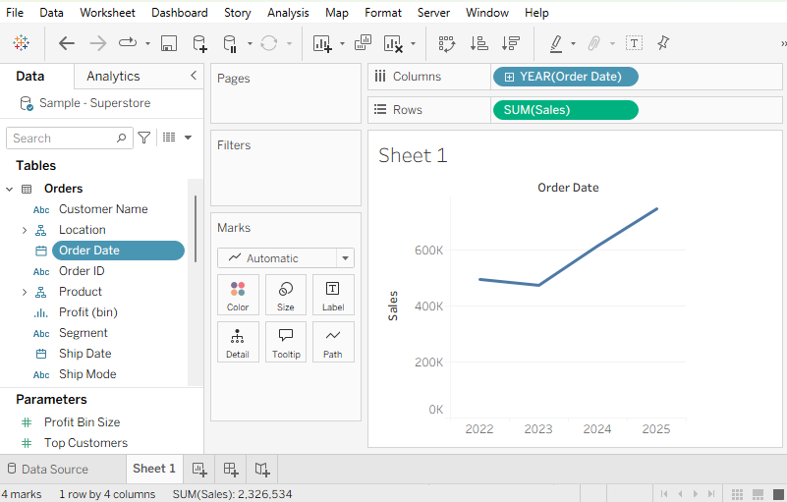
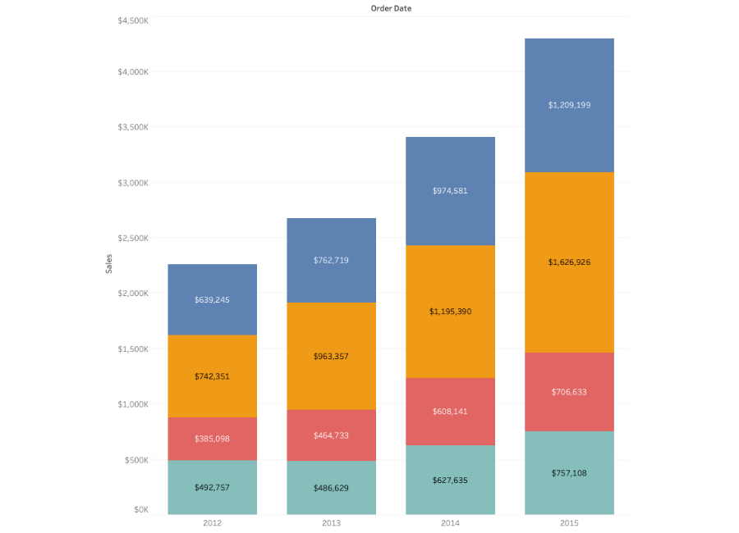
4
Steps
- Drag Category to Rows.
- Drag Sales to Columns.
- Tableau automatically creates a bar chart.
- If chart is different, click the Show Me panel on top right and select Bar.

B. Line chart: Sales over time
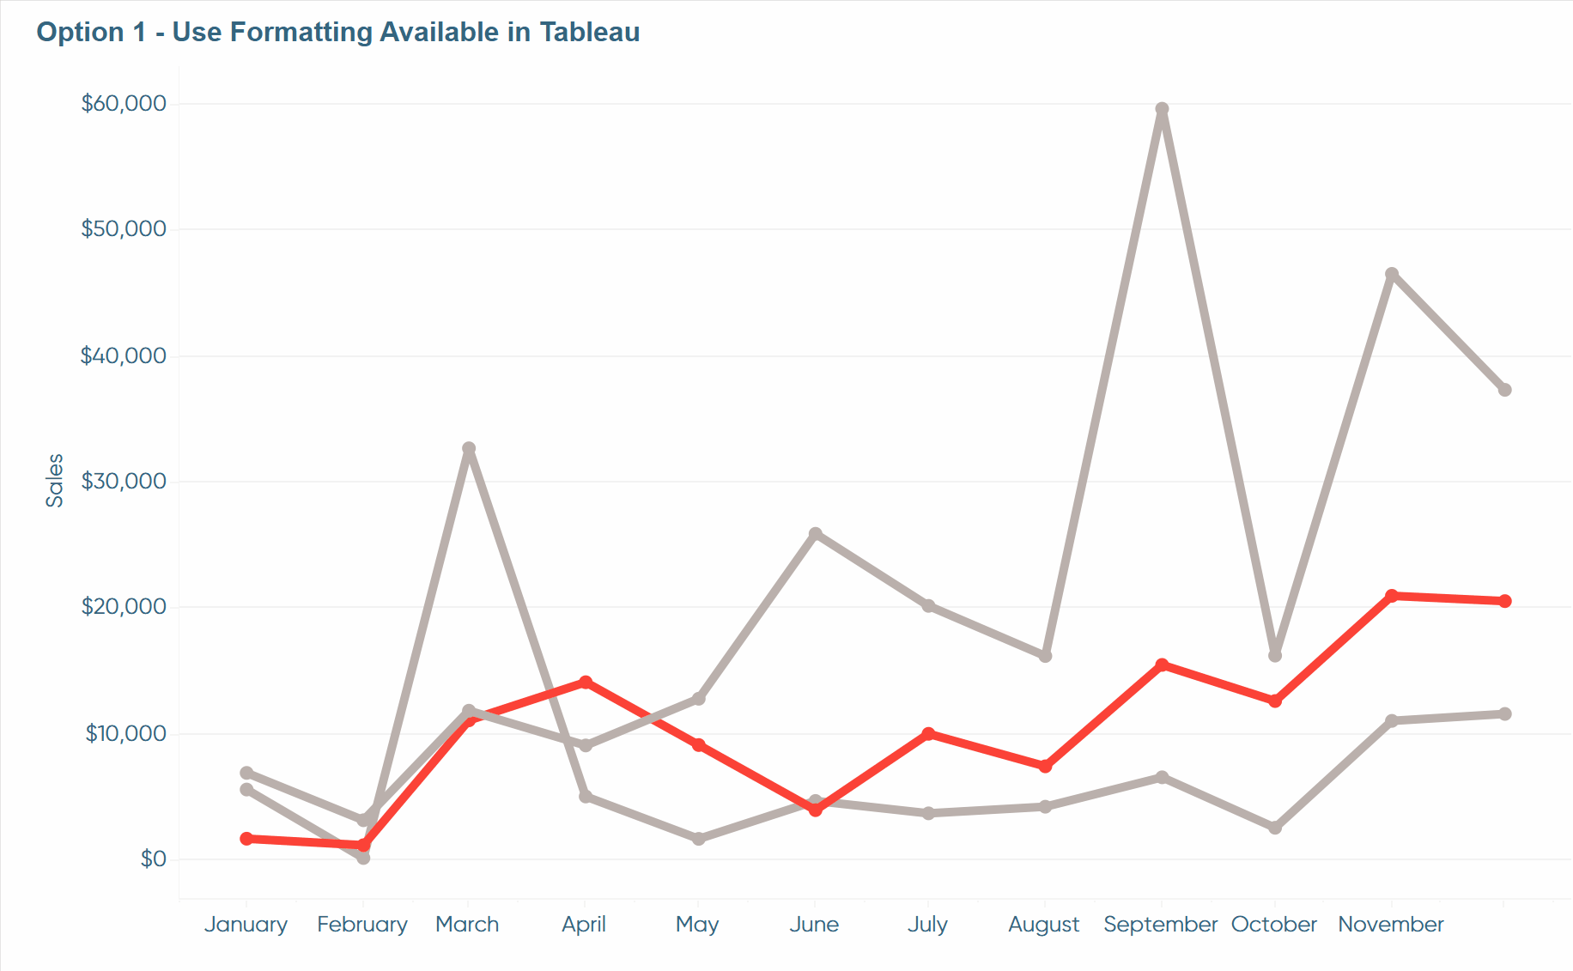
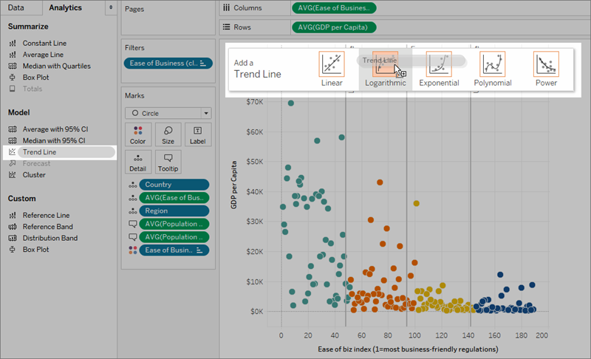
4
Steps
- Create a new sheet.
- Drag Order Date to Columns.
- Drag Sales to Rows.
- Tableau generates a time series line chart.

5. Sorting and Filtering Data
A. Sorting
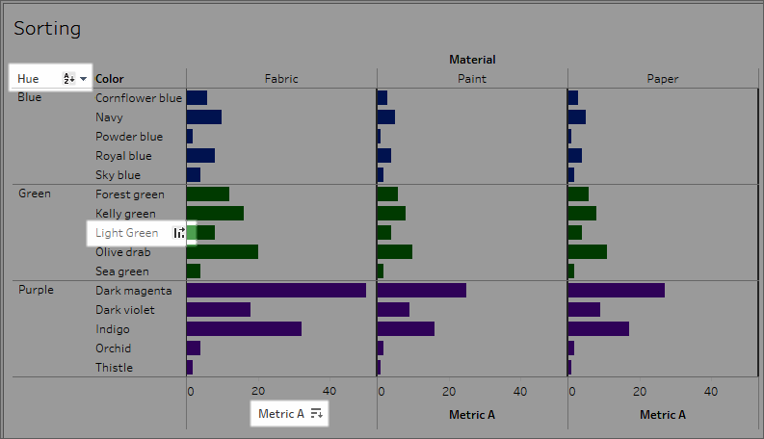
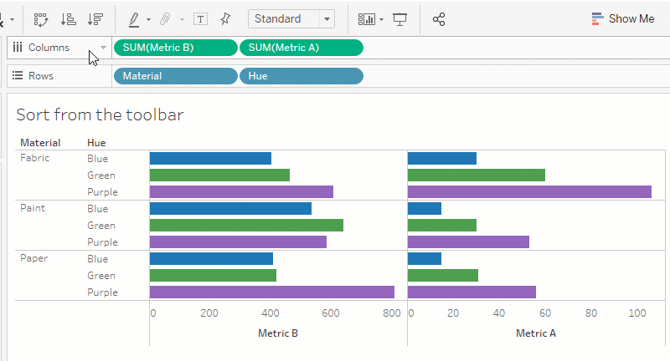
Steps
- Select your bar chart.
- Click the Sort icon above the visualization.
  - Ascending
  - Descending
- Bars reorder automatically.

B. Filtering
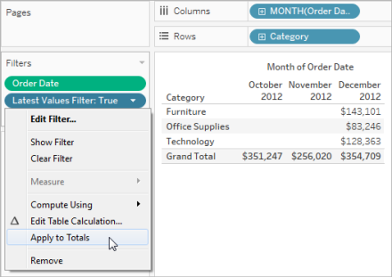
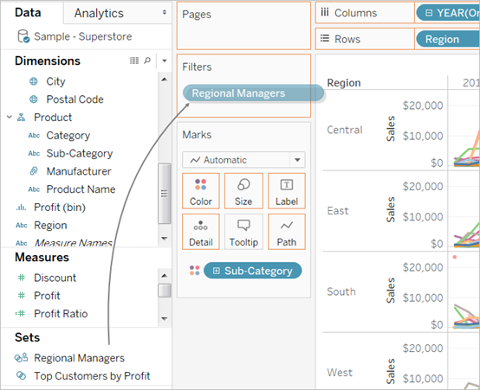
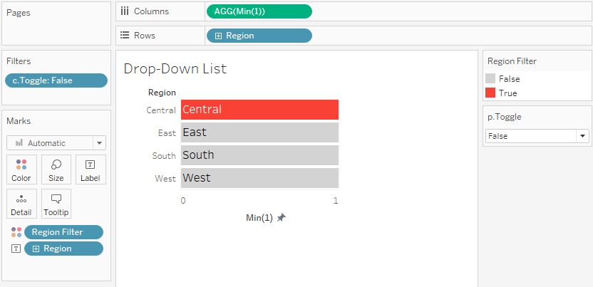
Steps
- Drag Region (or any dimension) to the Filters shelf.
- Select values you want included, for example:
  - Central
  - East
- Click OK.
- To show filter UI on the sheet:
  - Right click the field in Filters
  - Select Show Filter
- A filter box appears on the right.

